National Textile University, Faisalabad

Department of Computer Science
Name | Dawood Saif
Class | SE-6th (A)
Reg. No. | 23-NTU-CS-1145
Course | Mobile Application Development
Submitted To | Sir Rehan Sarwar
Submission Date | 02/03/2026
Lab Plan | 3

Lab Plan: Flutter Layout & Material Components

Task 1: Custom Cards and Icon Layouts
Objective: Master the Card widget's visual properties and child arrangement.
- Activity: Create three Card widgets with varying color properties and elevation values.
- Requirement: Each card must contain a Row or Column of multiple Icon widgets with different sizes and colors.

Code:
import 'package:flutter/material.dart';

void main() {
runApp(const MyApp());
}

class MyApp extends StatelessWidget {
const MyApp({super.key});

@override
Widget build(BuildContext context) {
return MaterialApp(
title: 'Task 1 - Custom Cards & Icon Layouts',
debugShowCheckedModeBanner: false,
theme: ThemeData(
colorScheme: ColorScheme.fromSeed(seedColor: Colors.deepPurple),
useMaterial3: true,
),
home: const Task1Page(),
);
}
}

class Task1Page extends StatelessWidget {
const Task1Page({super.key});

@override
Widget build(BuildContext context) {
return Scaffold(
appBar: AppBar(
title: const Text('Task 1: Custom Cards & Icon Layouts'),
backgroundColor: Colors.deepPurple,
foregroundColor: Colors.white,
),
body: SingleChildScrollView(
padding: const EdgeInsets.all(16),
child: Column(
children: [
// Card 1 – Blue background, elevation 2, Row of Icons
Card(
color: Colors.blue[100],
elevation: 2,
child: Padding(
padding: const EdgeInsets.all(16.0),
child: Column(
crossAxisAlignment: CrossAxisAlignment.start,
children: [
const Text(
'Card 1 | elevation: 2 | Row of Icons',
style: TextStyle(fontWeight: FontWeight.bold, fontSize: 14),
),
const SizedBox(height: 12),
Row(
mainAxisAlignment: MainAxisAlignment.spaceEvenly,
children: const [
Icon(Icons.home, size: 30, color: Colors.blue),
Icon(Icons.star, size: 45, color: Colors.amber),
Icon(Icons.favorite, size: 35, color: Colors.red),
Icon(Icons.settings, size: 40, color: Colors.grey),
Icon(Icons.camera_alt, size: 28, color: Colors.green),
],
),
],
),
),
),

const SizedBox(height: 16),

// Card 2 – Green background, elevation 8, Column of Icons
Card(
color: Colors.green[100],
elevation: 8,
child: Padding(
padding: const EdgeInsets.all(16.0),
child: Column(
crossAxisAlignment: CrossAxisAlignment.start,
children: [
const Text(
'Card 2 | elevation: 8 | Column of Icons',
style: TextStyle(fontWeight: FontWeight.bold, fontSize: 14),
),
const SizedBox(height: 12),
Row(
mainAxisAlignment: MainAxisAlignment.spaceAround,
children: [
Column(children: const [
Icon(Icons.cloud, size: 50, color: Colors.blueGrey),
SizedBox(height: 6),
Text('Cloud'),
]),
Column(children: const [
Icon(Icons.wb_sunny, size: 50, color: Colors.orange),
SizedBox(height: 6),
Text('Sunny'),
]),
Column(children: const [
Icon(Icons.thunderstorm, size: 50, color: Colors.indigo),
SizedBox(height: 6),
Text('Storm'),
]),
],
),
],
),
),
),

const SizedBox(height: 16),

// Card 3 – Purple background, elevation 14, mixed Row + Column
Card(
color: Colors.purple[50],
elevation: 14,
child: Padding(
padding: const EdgeInsets.all(16.0),
child: Column(
crossAxisAlignment: CrossAxisAlignment.start,
children: [
const Text(
'Card 3 | elevation: 14 | Row + Column Icons',
style: TextStyle(fontWeight: FontWeight.bold, fontSize: 14),
),
const SizedBox(height: 12),
Row(
mainAxisAlignment: MainAxisAlignment.spaceEvenly,
children: [
Column(children: const [
Icon(Icons.music_note, size: 36, color: Colors.pink),
Icon(Icons.headphones, size: 36, color: Colors.purple),
]),
Column(children: const [
Icon(Icons.sports_soccer, size: 36, color: Colors.green),
Icon(Icons.sports_basketball, size: 36, color: Colors.orange),
]),
Column(children: const [
Icon(Icons.book, size: 36, color: Colors.brown),
Icon(Icons.laptop, size: 36, color: Colors.blueAccent),
]),
],
),
],
),
),
),
],
),
),
);
}
}

Output Screenshot:
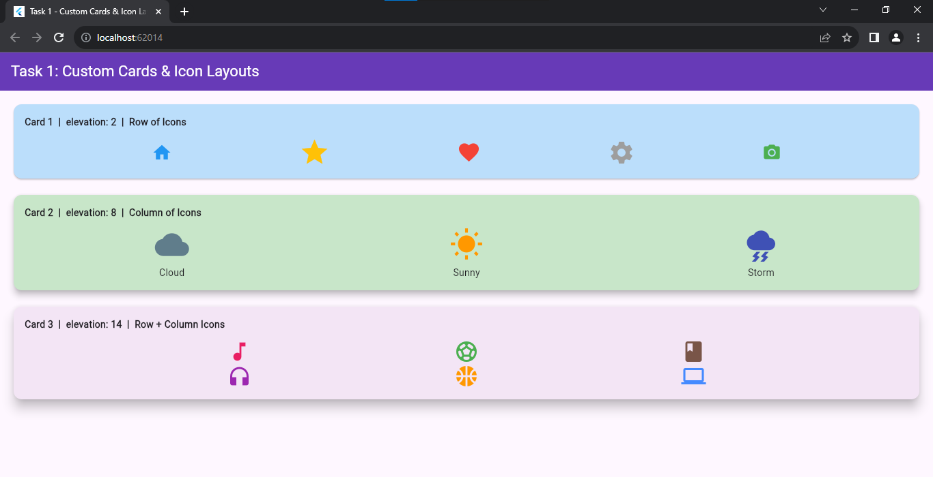

Task 2: Margin and Padding Implementation
Objective: Differentiate between internal (Padding) and external (Margin) spacing.
  - Activity: Create a Container with a background color and implement the following: All sides: Use padding: EdgeInsets.all(20.0).
  - Symmetric: Use margin: EdgeInsets.symmetric(vertical: 50.0, horizontal: 10.0).
  - Specific sides: Use EdgeInsets.only(left: 10) to add space only to the left.

Code:
import 'package:flutter/material.dart';

void main() {
runApp(const MyApp());
}

class MyApp extends StatelessWidget {
const MyApp({super.key});

@override
Widget build(BuildContext context) {
return MaterialApp(
title: 'Task 2 - Margin & Padding',
debugShowCheckedModeBanner: false,
theme: ThemeData(
colorScheme: ColorScheme.fromSeed(seedColor: Colors.teal),
useMaterial3: true,
),
home: const Task2Page(),
);
}
}

class Task2Page extends StatelessWidget {
const Task2Page({super.key});

@override
Widget build(BuildContext context) {
return Scaffold(
appBar: AppBar(
title: const Text('Task 2: Margin & Padding'),
backgroundColor: Colors.teal,
foregroundColor: Colors.white,
),
body: SingleChildScrollView(
child: Column(
crossAxisAlignment: CrossAxisAlignment.start,
children: [

// ── Section 1: padding all sides ──────────────────────────
const Padding(
padding: EdgeInsets.fromLTRB(12, 16, 12, 4),
child: Text(
'1. padding: EdgeInsets.all(20.0)',
style: TextStyle(fontWeight: FontWeight.bold, fontSize: 15),
),
),
// Outer orange shows where the container sits; inner shows the padding space
Container(
color: Colors.orange[200],
child: Padding(
padding: const EdgeInsets.all(20.0),
child: Container(
width: double.infinity,
color: Colors.orange[600],
padding: const EdgeInsets.all(12),
child: const Text(
'Inner Container\npadding: EdgeInsets.all(20.0)',
style: TextStyle(color: Colors.white, fontSize: 14),
),
),
),
),

const SizedBox(height: 8),

// ── Section 2: margin symmetric ───────────────────────────
const Padding(
padding: EdgeInsets.fromLTRB(12, 16, 12, 4),
child: Text(
'2. margin: EdgeInsets.symmetric(vertical: 50, horizontal: 10)',
style: TextStyle(fontWeight: FontWeight.bold, fontSize: 15),
),
),
Container(
margin: const EdgeInsets.symmetric(vertical: 50.0, horizontal: 10.0),
width: double.infinity,
color: Colors.teal[400],
padding: const EdgeInsets.all(16),
child: const Text(
'Container\nmargin: symmetric(vertical: 50, horizontal: 10)',
style: TextStyle(color: Colors.white, fontSize: 14),
),
),

// ── Section 3: margin only left ───────────────────────────
const Padding(
padding: EdgeInsets.fromLTRB(12, 16, 12, 4),
child: Text(
'3. margin: EdgeInsets.only(left: 10)',
style: TextStyle(fontWeight: FontWeight.bold, fontSize: 15),
),
),
Container(
margin: const EdgeInsets.only(left: 10),
width: double.infinity,
color: Colors.pink[300],
padding: const EdgeInsets.all(16),
child: const Text(
'Container\nmargin: EdgeInsets.only(left: 10)',
style: TextStyle(color: Colors.white, fontSize: 14),
),
),

const SizedBox(height: 24),
],
),
),
);
}
}

Output Screenshot:
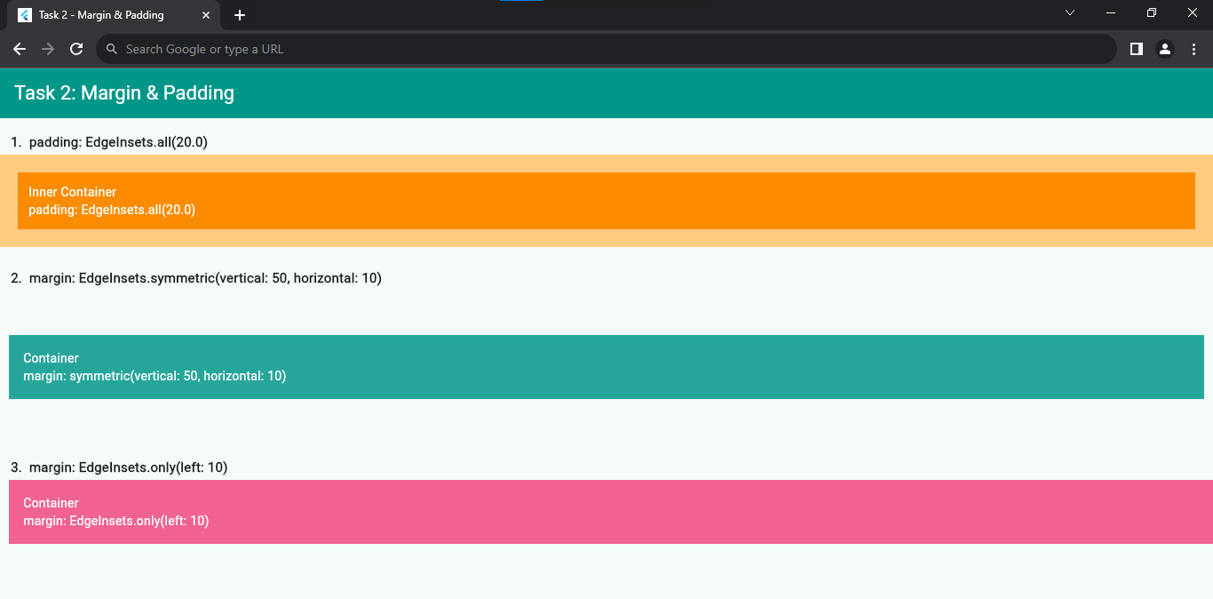

Task 3: Profile UI with CircleAvatar
Objective: Implement user identity visuals in different UI areas.

  - Activity: Place a CircleAvatar in the body that loads a profile image via NetworkImage.
  - Place a second CircleAvatar within the AppBar (typically in the actions or leading property) using AssetImage for a local file.

  - Requirement: Ensure the avatar correctly represents a user profile or initials if the image fails to load.
Code:
import 'package:flutter/material.dart';

void main() {
runApp(const MyApp());
}

class MyApp extends StatelessWidget {
const MyApp({super.key});

@override
Widget build(BuildContext context) {
return MaterialApp(
title: 'Task 3 - Profile UI with CircleAvatar',
debugShowCheckedModeBanner: false,
theme: ThemeData(
colorScheme: ColorScheme.fromSeed(seedColor: Colors.deepPurple),
useMaterial3: true,
),
home: const Task3Page(),
);
}
}

class Task3Page extends StatelessWidget {
const Task3Page({super.key});

@override
Widget build(BuildContext context) {
return Scaffold(
appBar: AppBar(
backgroundColor: Colors.deepPurple,
foregroundColor: Colors.white,
title: const Text('Task 3: Profile UI'),

// ── CircleAvatar in AppBar leading using AssetImage (initials fallback) ──
leading: const Padding(
padding: EdgeInsets.all(8.0),
child: CircleAvatar(
backgroundColor: Colors.white,
// Replace with AssetImage('assets/profile.png') if you have a local asset
backgroundImage: NetworkImage(
'https://picsum.photos/seed/abc/200/200',
),
child: null,
),
),

// ── CircleAvatar in AppBar actions using NetworkImage ──
actions: [
Padding(
padding: const EdgeInsets.only(right: 12.0),
child: CircleAvatar(
radius: 18,
backgroundColor: Colors.deepPurple[200],
backgroundImage: const NetworkImage(
'https://picsum.photos/seed/xyz/200/200',
),
),
),
],
),

body: Center(
child: Column(
mainAxisAlignment: MainAxisAlignment.center,
children: [
// ── CircleAvatar in Body with NetworkImage ──
const CircleAvatar(
radius: 70,
backgroundImage: NetworkImage(
'https://picsum.photos/seed/profile/300/300',
),
),

const SizedBox(height: 16),

const Text(
'Dawood Saif Cheema',
style: TextStyle(fontSize: 24, fontWeight: FontWeight.bold),
),
const SizedBox(height: 4),
const Text(
'cheemadawood40@gmail.com',
style: TextStyle(fontSize: 14, color: Colors.grey),
),
const SizedBox(height: 4),
const Text(
'Reg No: 23-NTU-CS-1145',
style: TextStyle(fontSize: 14, color: Colors.grey),
),

const SizedBox(height: 40),
const Divider(indent: 40, endIndent: 40),
const SizedBox(height: 8),

const Text(
'AppBar leading → CircleAvatar (AssetImage / NetworkImage)',
style: TextStyle(color: Colors.grey, fontSize: 12),
),
const Text(
'AppBar actions → CircleAvatar with NetworkImage',
style: TextStyle(color: Colors.grey, fontSize: 12),
),
const Text(
'Body → CircleAvatar with NetworkImage (large)',
style: TextStyle(color: Colors.grey, fontSize: 12),
),
],
),
),
);
}
}

Output Screenshot:
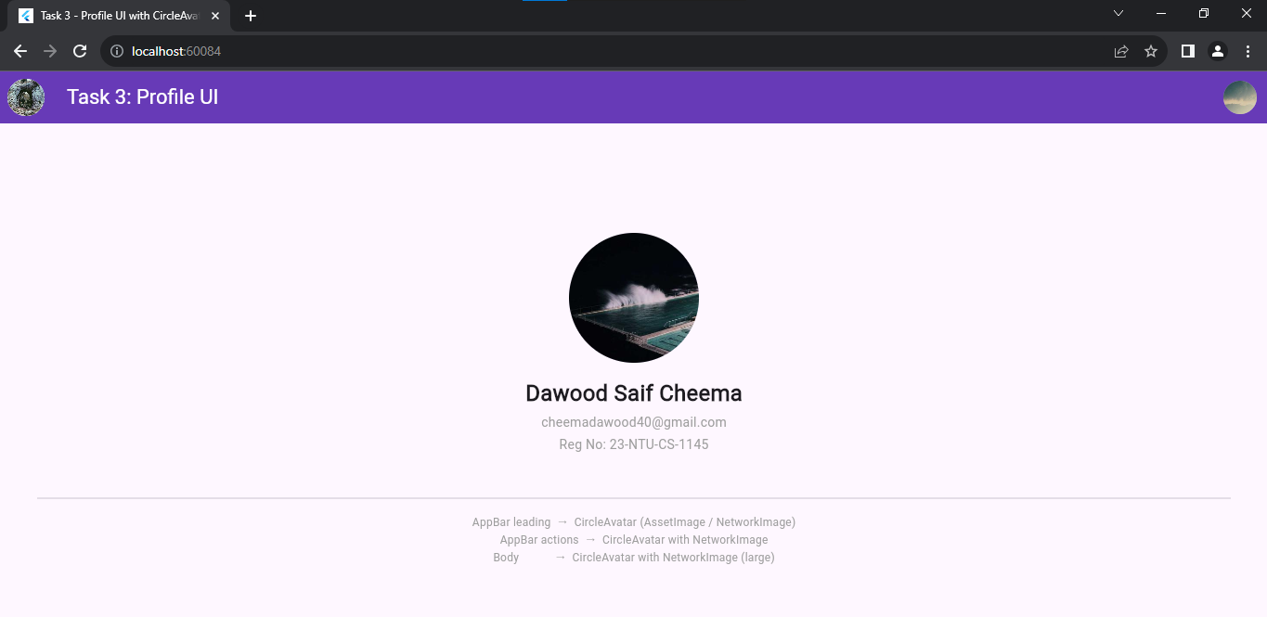

Task 4: Information Grouping with Card & ListTile
Objective: Use ListTile to create structured, repeatable UI elements.
Activity: Create a Card with rounded corners and an elevation shadow. Inside the Card, nest a ListTile.
    - Requirement:
Leading: Use an Icon or CircleAvatar.
Title: Contact name.
Subtitle: Registration No.
Variations: Create a second version with a different color scheme and a trailing icon.

Code:
import 'package:flutter/material.dart';

void main() {
runApp(const MyApp());
}

class MyApp extends StatelessWidget {
const MyApp({super.key});

@override
Widget build(BuildContext context) {
return MaterialApp(
title: 'Task 4 - Card & ListTile',
debugShowCheckedModeBanner: false,
theme: ThemeData(
colorScheme: ColorScheme.fromSeed(seedColor: Colors.indigo),
useMaterial3: true,
),
home: const Task4Page(),
);
}
}

class Task4Page extends StatelessWidget {
const Task4Page({super.key});

@override
Widget build(BuildContext context) {
return Scaffold(
appBar: AppBar(
title: const Text('Task 4: Card & ListTile'),
backgroundColor: Colors.indigo,
foregroundColor: Colors.white,
),
body: SingleChildScrollView(
padding: const EdgeInsets.all(16),
child: Column(
crossAxisAlignment: CrossAxisAlignment.start,
children: [

// ── Version 1: Icon as Leading, no trailing ────────────
const Text(
'Version 1 – Icon Leading',
style: TextStyle(fontWeight: FontWeight.bold, fontSize: 15),
),
const SizedBox(height: 8),

Card(
shape: RoundedRectangleBorder(
borderRadius: BorderRadius.circular(16),
),
elevation: 6,
child: ListTile(
contentPadding:
const EdgeInsets.symmetric(horizontal: 20, vertical: 10),
leading: const Icon(
Icons.person,
size: 42,
color: Colors.indigo,
),
title: const Text(
'Dawood Saif',
style: TextStyle(fontWeight: FontWeight.bold, fontSize: 16),
),
subtitle: const Text('Registration No: 23-NTU-CS-1145'),
),
),

const SizedBox(height: 28),

// ── Version 2: CircleAvatar Leading + Trailing Icon ────
const Text(
'Version 2 – CircleAvatar Leading + Trailing Icon (Different Color Scheme)',
style: TextStyle(fontWeight: FontWeight.bold, fontSize: 15),
),
const SizedBox(height: 8),

Card(
shape: RoundedRectangleBorder(
borderRadius: BorderRadius.circular(16),
),
elevation: 6,
color: Colors.teal[50],
child: ListTile(
contentPadding:
const EdgeInsets.symmetric(horizontal: 20, vertical: 10),
leading: const CircleAvatar(
radius: 26,
backgroundColor: Colors.teal,
child: Text(
'DS',
style: TextStyle(
color: Colors.white,
fontWeight: FontWeight.bold,
fontSize: 18,
),
),
),
title: const Text(
'Dawood Saif',
style: TextStyle(
fontWeight: FontWeight.bold,
fontSize: 16,
color: Colors.teal,
),
),
subtitle: const Text(
'Registration No: 23-NTU-CS-1145',
style: TextStyle(color: Colors.teal),
),
trailing: const Icon(Icons.phone, color: Colors.teal),
),
),

],
),
),
);
}
}

Output Screenshot:
